Communities 4 Families

Annual Report 2019-2020

Communities 4 Families meets monthly for networking opportunities and to learn about resources in the downtown that would be appropriate for agencies’ participant families. Presentations by various agencies are an important part of our learning. One or two agencies present at each of our monthly meetings in addition to roundtable sharing. Presenters this year have been:

* Leslie Richards, City of Winnipeg
* Carrie Costello, familiesforward and BRIGHT coaching
* And we presented our WGM Updated Manual

One of our meetings was a Parenting Panel, which highlighted various parenting programs available downtown:

* Traditional Parenting
* Positive Discipline in Everyday Parenting (PDEP) - (Mosaic)
* HIPPY (Home instruction for Parents of Pre-School youngsters) – (Mosaic)
* Bounce Back and Thrive (Mosaic)
* Circle of Security (Thrive Community Support Circle)
* Working with CFS (Thrive Community Support Circle)
* Dad’s Parenting (Thrive Community Support Circle)
* Nobody’s Perfect (Wolseley Family Place)
* Handle with Care (Wolseley Family Place)
* Parents Exploring Anger (Wolseley Family Place)
* Working with CFS “Having a good visit with your child in care” (New Directions)
* Parent Coach program and In-Home Support (Family Dynamics)
* Newcomer support (Aurora Family Therapy Centre)

In January, instead of our annual strategic planning day, we invited Lisa Murdock, from Healthy Child Manitoba, to sit with us in planning our next 6 months. We looked at what was appreciated about the work of Communities 4 Families and which were the most important aspects for the community. If funding would not continue past September 30, we considered the options before us – what we could continue in some way, and what we could hand over to agencies.

Our Annual General Meeting was held in June. We focused on grants supporting Family Literacy downtown and had brief presentations by:

• Aurora Family Therapy –3 Stars and a Wish

• Mosaic Newcomer Family Resource Network – Family Literacy events in summer

• Thrive Community Support Circle - Book Bags program

• Winnipeg Inner City Missions – Learn and Play Program

41 participants attended our monthly meetings, representing 19 different downtown agencies. Most come to find out about other agencies, share information about their own agencies, and to participate in the Committee work of the Coalition.

An ad hoc committee continues to look at our response to the TRC Recommendations. We did a short survey of agencies to see what is happening downtown and asked grantees to report on their activities related to the TRC recommendations. We devoted one meeting to agencies sharing about their own indigenous programming and/or what resources they knew of that would assist others. A Building Cultural Competency workshop was planned for March 16 but was cancelled/postponed due to the COVID-19 crisis.

**Executive Committee**

The Executive Committee met monthly. They planned the AGM, reviewed grant criteria, made final decisions on grants applications, and worked on HR Policy. They planned the January planning meeting and decided to put out an additional call for grants.

Our AGM happened in June 2019. 25 people attended, from 19 different agencies. Cheryl Starr and Jess Smith agreed to act as co-chairs for the coming year.

**Total grants awarded: $48,627**

* $29,326 - Parent/child programs
* $10,389 - Parenting programs
* $5,483 - Family Literacy programs
* $3,429 – Facilitator training

**Resource Committee**

Downtown agencies identified the need for staff development, so this Committee is tasked with developing a schedule of workshops that meet a need for downtown agencies.

After developing, running, and mentoring the WGM program for nearly 15 years, our manual has been updated. A photo shoot with families provided excellent pictures that can be used in the manual and for promotions. The [updated manual](http://communities4families.ca/wp-content/uploads/2017/07/C4F_Baby-Book_LR-Spreads-REVISED.pdf) was released at our September members’ meeting and given to member agencies and anyone taking our WGM facilitators’ training and refresher classes in October 2019.

We held two WGM facilitator trainings, in October and February.

The Resource Committee continued to provide mentorship to WGM programs in the community. 3 facilitator meetings (with 31 participants) providing “Professional Development” were held this year. 2 facilitator “refreshers” (15 participants) were also held.

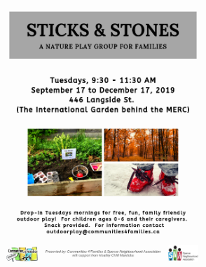7 WGM programs groups ran from April through March. We estimate that approximately 100 families with around 200 children attend these programs every year.

Staff explored outdoor play with downtown families in an Outdoor Play program, with a goal of getting parents and children outdoors in all kinds of weather. In partnership with Spence Neighbourhood Association, *Sticks & Stones*, an outdoor play drop-in began, attracting 4-8 families weekly. A workshop was also developed and shared with downtown agencies, to encourage families to play outside.

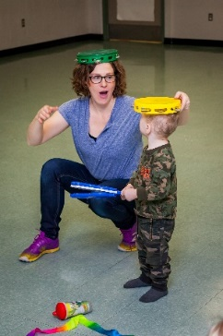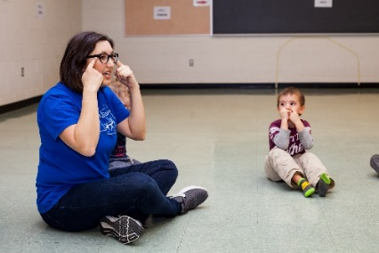After many years with us, Kelly Speak, our trainer/mentor, left her position and Katie Anderson took over the role. The Committee assisted with this transition. In her position, Katie continues to provide training and support for WGM programs, focusing on mentorship for running both those programs and Sticks & Stones.

A partnership with Healthy Start for Mom and Me is growing. Katie is working with them to offer WGM for their parents when they age out of their current programming.

$3450 in training bursaries were offered to agencies. 22 people from 5 different agencies were trained in Traditional Parenting, Nobody’s Perfect, and Play to Learn, Learn to Play.

**Literacy Committee**

We continue to resource agencies with our [*I Love it When…*](http://communities4families.ca/wp-content/uploads/2019/10/C4F-Wiggle-Giggle-Munch-Manual-FINAL-web.pdf) and [*Time to Play!*](http://communities4families.ca/wp-content/uploads/2019/05/Spring-2019.pdf) books. In the downtown, Public Health nurses share them with families and community groups share the books with participants.

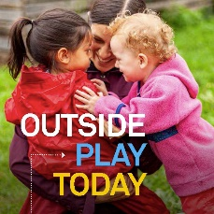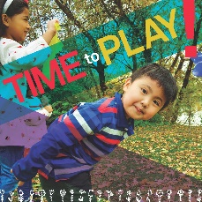

In partnership with familiesforward (River Heights/Fort Rouge Parent Child Coalition), an ad hoc committee was struck to develop a third Book 4 Babies, focusing on numeracy. The book, [*Outside Play*](http://communities4families.ca/wp-content/uploads/2017/07/I_Love_It_Book_ENG_FR_tk109.pdf?dl=0) *Today* was written and illustrated through a local photo shoot, ready for distribution by familiesforward and our own Coalition.

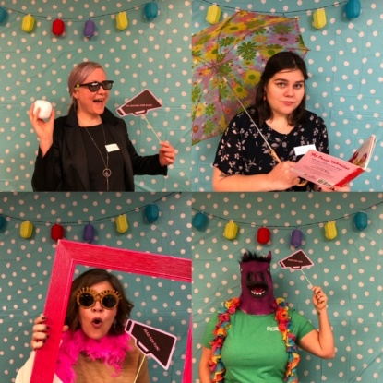

Our 10th annual Family Literacy day happened in January. We hosted 155 people, the largest attendance ever. Bus transportation from Mosaic and IRCOM helped to get families to this winter event.

Our coordinator was asked to sit on the committee deciding on Literacy for Life grants, an opportunity to share the knowledge of the Coalition with the broader community.

**Communications**

Three issues of *Downtown Parents* were published, highlighting downtown programs of interest to parents; giving some tools and information; and advertising upcoming C4F events. The [spring issue](http://communities4families.ca/resources-4-families/) highlighted various free parenting and parent/child programs for downtown families. The [fall issue](https://www.dropbox.com/sh/o3wp8t01bz1jhjd/AAClaU39-Xn6Z3u0UCfvbemja?dl=0) highlighted various free parenting and parent/child programs for downtown families. The [winter issue](https://www.dropbox.com/s/6yczw24spgv4okj/C4F%20Outside%20Play%20Today%20FINAL_WEB.pdf?dl=0) focused on family literacy and the Family Literacy Day celebration in January. We print 2500 copies of each newsletter, which are distributed to approximately 60 downtown agencies. The newsletter is also available electronically on our website and sent through our weekly digest.

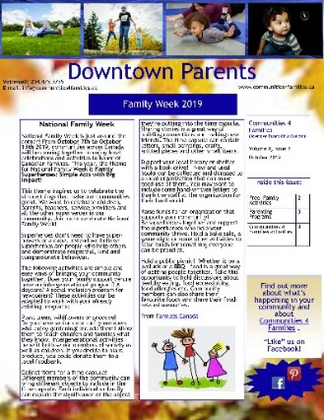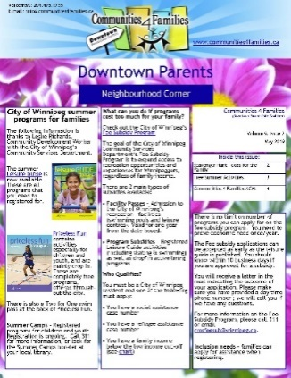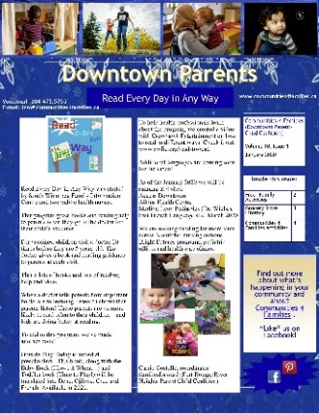

We continue to keep the website up to date and share Facebook posts that are aimed to inform downtown families. A weekly email digest is sent to over 100 recipients representing 50 downtown agencies. This includes information about research, training opportunities, and any other pertinent information for agencies as well as free, local activities for families of young children.

The [website](http://communities4families.ca) is visited an average of 166 times/month, about 1500 times in a year. Most visits are to the [Resources 4 Families](https://www.dropbox.com/s/h2n4tm9wr6tet1y/Winter%202020.pdf) section as well as the events calendar listing the WGM groups we support and mentor.