
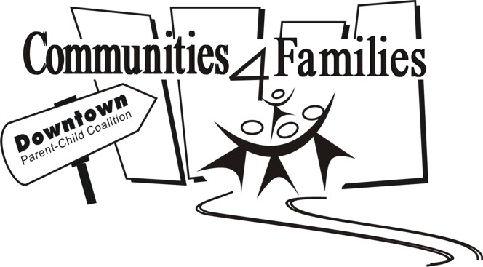
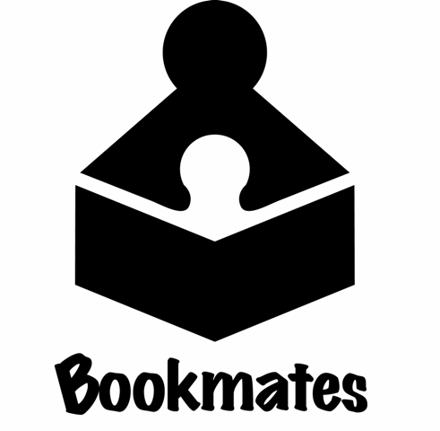
1 Day Workshop
Play to Learn
Learn to Play
Thursday, December 3, 2015
9:30 a.m. — 3:30 p.m.

623 Erin St (in the Erin Square mall) @ Bookmates

Play to Learn, Learn to Play is a family learning model based on the value of play. Let’s set our young children up for success in helping them lead healthy, active lifestyles – giving them lots of free, unstructured play times!

By the end of the workshop you will:

- Explore the value of play and the philosophy behind child-led play
- Receive your own manual providing session plans, games, tips, statistical facts and parent handouts needed to run your own Play to Learn, Learn to Play family program
- Understand how play helps children with reading, writing, math and language development
Cost: Training is generously supported by Healthy Child Manitoba. A $10 fee is charged to help cover the cost of lunch.

This is a training workshop for adults only. Unfortunately, childcare is not provided. Priority will be given to those living and working in the downtown.

Registration forms and payment must be received before space in the training is confirmed.

Registration deadline: November 26, 2015

Name:

Organization (if you are representing one):

Address:

Phone:

Email Address:

Lunch will be provided for this training. Please let us know if you have special dietary needs:

Will you be running a family program for your organization?

This training is limited to 16 participants.
We will confirm your registration by phone, email or fax.

- Email Registrations to ingrid@communities4families.ca

- or Fax Registrations to: 204.487.3630 – Attention: Ingrid

- or Mail Registrations to: Communities 4 Families 823 Ellice Avenue Winnipeg, MB R3G 0C3 Attention: Ingrid

Please make cheques ($10) out to ‘Klinic’ or to pay by credit card call Marge at Klinic @ 204.784.4007. For all other inquiries please email ingrid@communities4families.ca or leave a message at 204.475.5755.
Bookmates contact: 204.582.1804; bookmate@mts.net

